Ryan Smith
Ambassador Kamal
Seton Hall University
April 1, 2008
SHU-UNSC-RS-Resolution 1441
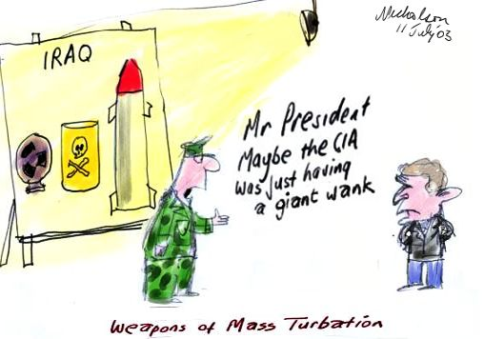

RESOLUTION 1441 OUTLINE FOR April 1, 2008

Introduction

The purpose of this outline is to provide an overview of UN Security Council’s (SC) Resolution 1441 and analyze its consequences.

Facts

Resolution begins by condemning Iraq, the Arab League and the Secretary General in regards to Iraq and weapons of mass destruction
- Iraq is in breach of commitments to inspections and IAEA
- Final chance for disarmament and enhanced inspections
- Within 30 days of resolution passing, Iraq should report all facilities and capabilities to UNMOVIC, IAEA and Security Council
- False statements or omission will be considered a further breach and SC will evaluate what actions should be taken
- Iraq will allow UNMOVIC and IAEA unlimited access for inspections
- Endorses letter from Directors of UNMOVIC and IAEA (will be passed out in class)
- SC gives UNMOVIC and IAEA access to complete their jobs
- Iraq will not take action against member states, UN personal or IAEA workers committed to this resolution
- Sec. General will notify Iraq of resolution, giving Iraq 7 days to reply with its intention to comply with the resolution
- Requests all member states to aid UNMOVIC and IAEA in fulfilling their mandates
- IAEA and UNMOVIC shall report any hindrance by Iraq to the SC
- Will convene immediately after reports have been received
- Iraq will face “serious consequences” for failure to comply

Analysis
The United States sought to use the United Nations and weapons of mass destruction as a means of going into Iraq and removing the government. The language in the resolution allows for “serious consequences” for failure to comply with any part of the resolution. Acting with IAEA and UNMOVIC, the United States sought legitimacy in its claims that Iraq had weapons of mass destruction and failed to comply with Security Council sanctions.

Conclusion
Iraq’s failure to comply is troublesome to the UNSC. The United States and the UNSC hoped for disarmament and establishing peace and security in Iraq, reaching through the Middle East. The US sought to use Iraq as an example for other nations such as Iran, however the failure, and subsequent war not sanction by the UN proved taxing on the USA.

