Ryan Smith
Ambassador Kamal
Seton Hall University
April 1, 2008
SHU-UNSC-RS-Resolution 678
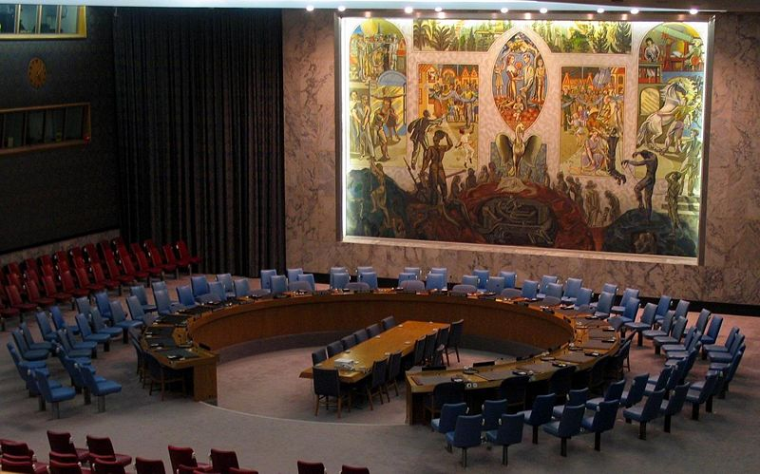

RESOLUTION 678 OUTLINE FOR April 1, 2008

Introduction

The purpose of this outline is to provide an overview of UN Security Council’s (SC) Resolution 678 and analyze its consequences.

Facts

In November of 1990, referring to the Iraq’s failure to comply with Resolution 660 and corresponding Resolutions 660, 661, 662, 664, 665, 666, 667, 669, 670, 674, and 677, the UNSC passed Resolution 678.
- The aim of the resolution was to give Iraq one final chance to comply with Resolution 660 and the concurring resolutions listed above.
- Allowed member states, acting with the government of Kuwait to act if Iraq failed to comply with the resolutions by 15 January 1991 to use “all necessary means” to make Iraq comply with resolution 660 and the corresponding resolutions in order to “restore international peace and security”
- Requests all member states give the necessary support to make Iraq comply
- All member states should keep the security council informed of any action they take in regards to making Iraq comply and enforcing this resolution
- The United Nations Security Council: “Decides to remain seized of the matter.”

Analysis
In Iraq’s failure to comply with Resolution 660 and the corresponding resolutions, which followed it, the United Nations Security Council gave Iraq one final chance to comply. This resolution carries weight for several reasons. First, it acts as a condemnation of Iraq for failure to comply, second, it enables the Security Council and member states to act in extreme nature “by any means necessary” in aiding Kuwait in regards to the above mentioned resolutions. Third, it enforces the severity to which the Security Council dealt with the issue, calling all states to inform the Security Council about actions they would take. Finally, it shows that the Security Council will carefully monitor the situation and act accordingly.

Conclusion
Iraq’s failure to comply is troublesome to the UNSC. The Security Council remains committed to enforcing their regulations and using force if necessary to uphold their duty in the United Nations Charter of enforcing international peace and security.

