Ryan Smith
Ambassador Kamal
Seton Hall University
April 1, 2008
SHU-UNSC-RS-Resolution 687
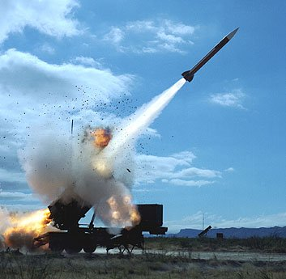

RESOLUTION 687 OUTLINE FOR April 1, 2008

Introduction

The purpose of this outline is to provide an overview of UN Security Council’s (SC) Resolution 687 and analyze its consequences.

Facts

In April of 1991, Recalling its resolutions 660,661, 662, 664, 665, 666, 667, 669, 670, 674, 677, 678 and 686- dealing with Iraq and Kuwait and recognizing a list of international commitments made by the government of Iraq
- 34 pieces to the resolution
  - 13 resolutions will be achieved, including formal cease fire
  - Recognize international boundary and allocation of islands
  - Secretary General to aid and report back to SC in response to boundaries
  - Support the boundaries established
  - S. General will report to SC for immediate deployment of observer unit
  - S. General will report to SC with observer unit and end military presence
  - Asks Iraq to comply with Geneva Protocol- and removal of weapons
  - Sets up the implementation of removal of weapons
  - Iraq shall not develop or acquire the weapons listed above
  - Iraq should comply with non-proliferation treaty
  - Iraq shall not develop nuclear weapons and all nuclear materials shall be regulated by IAEA
  - IAEA to complete inspections related to materials
  - In compliance with above, Middle East free of WMD
  - S. General to report to SC on return of Kuwaiti property
  - Iraq responsible for loss and damages (including environmental damage) due to invasion of Kuwait
  - Iraq statements regarding foreign debt before Aug. 2, 1990 are null and void
  - Fund for par. 16, and commission to disperse funds
  - S. Gen. to create a plan in 30 days for fund payments
  - Sanctions against Iraq (SC will review sanctions every 60 days), SC can end sanctions, SC committee under res. 661 can allocate funds
  - Iraq shall work with Int. Red Cross to help Kuwait
  - Iraq will not support terrorism
  - With Iraq’s accordance to this resolution, a ceasefire with Kuwait will occur
  - Remain seized on the matter

Analysis
A far-reaching and lengthy resolution, UNSC Resolution 687 shows the UNSC’s commitment to ending the conflict between Iraq and Kuwait. Additionally, language about terrorism and weapons of mass destruction are also mentioned in the resolution. This resolution, if carried out by Iraq would eliminate questions regarding their weapons production and commitment to international peace. It also has teeth, if needed, to take necessary actions such as far reaching sanctions against Iraq to enforce compliance.

Conclusion
One of the SC’s most far reaching resolutions, Resolution 687 ensures the Security Council’s commitment to enforcing their previous resolutions regarding the Iraq/Kuwait conflict. The sanctions and language used are strong, and in the eyes of the Security Council necessary to ensure the international commitment to peace and security.

