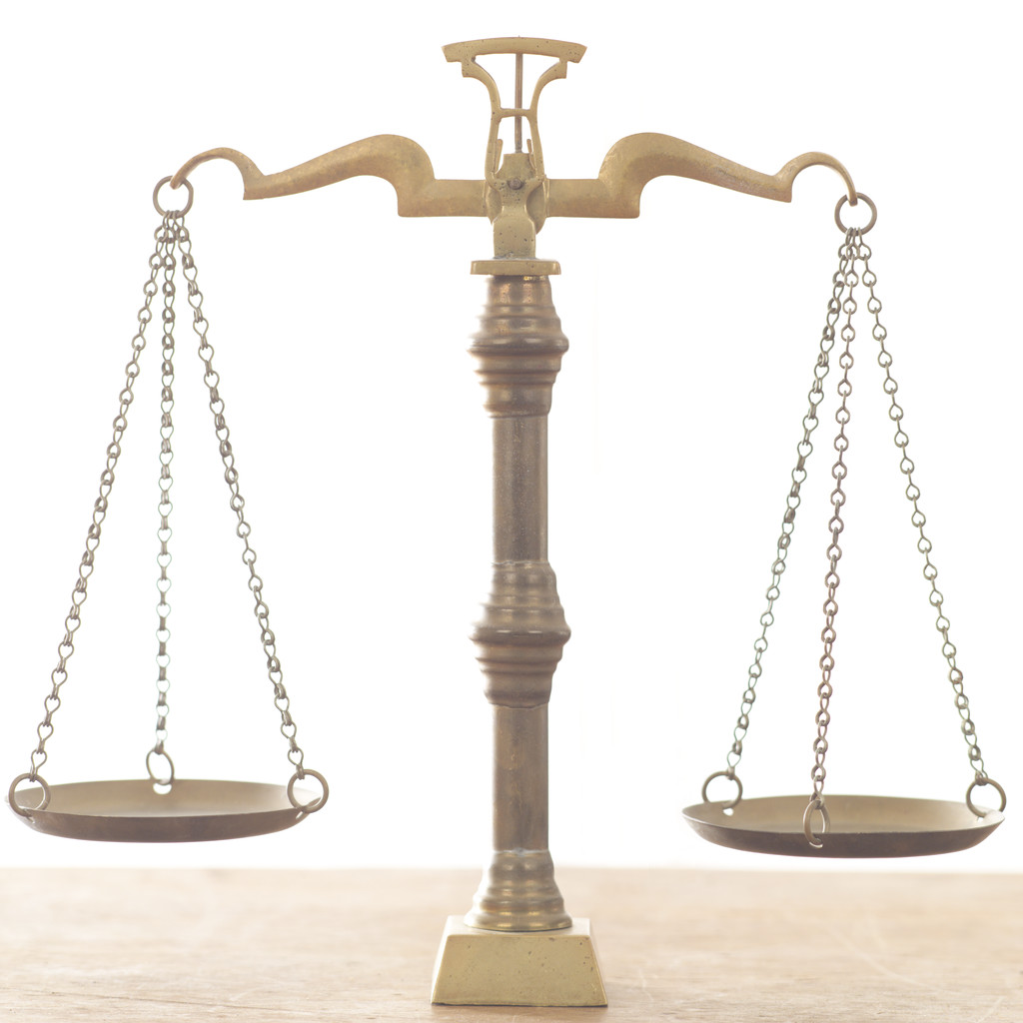
Ryan Smith
Ambassador Kamal
Seton Hall University
03-12-08
UN-SC-RDS-Paper Extended Outline
Security Council Paper Extended Outline

Thesis Statement:
The United Nations Security Council is one of the least understood, most powerful bodies in the international community. This organization decides not only what they will debate on, but also, in so doing, decide what the United Nations General Assembly can and cannot pass resolutions on or debate openly. This extreme power comes with extreme consequences. From the beginning of the Security Council and the United Nations, there has been debate on this all powerful group, especially the P-5, the permanent, veto carrying members of the group (China, France, Russia, United Kingdom, and the United States of America). This paper will examine the use of the veto by these five permanent members and consequently, the growth and use of the abstention vote concerning issues the Security Council debates. Transition The use of the abstention, as in Resolution 1706 allows Security Council resolutions to pass even when Council members object to all or part of a resolution.

Intro:
Security Council Resolution 1706 is an interesting case study in international relations. This resolution, passed to resolve the Sudanese conflict in Darfur is interesting for many reasons. Passed on August 31, 2006, Security Council Resolution 1706 will increase the United Nations involvement in Sudan, providing 22,500 peacekeeping troops and police officers to Darfur in an effort to maintain global peace and security. For this paper, Security Council Resolution 1706 is helpful to understand the use of abstention, both by Permanent members of the Security Council and by nonpermanent members. Resolution 1706 passed with three abstentions, two from Security Council members, China and Russia, and one from a nonpermanent member, Qatar.
Resolution 1706- Sudan
- Passed 31 August 2006
- Resolve Darfur conflict
- 22,500 troops and police officers supplied by the UN
- Votes
  - 12 approved
  - 3 abstentions (People’s Republic of China, Qatar and Russian Federation)
    - China- African Union had supported Darfur- supports UN involvement- China imports over 60% of Sudan oil and is involved in oil exploration projects
    - Qatar- warned of sovereignty rights of Sudan- resolution written too quickly
    - Russian Federation- Sudanese government must agree to action- did not object to content of resolution- Russia is a main supplier of arms to Sudan
- Two types of Security Council Resolutions- Chapter 6 and Chapter 7

Facts:
Voting in the Security Council
Voting in the United Nations Security Council is somewhat of a mystery. While states make comments or hold press conferences as to the reasoning for their votes, the rules under which voting occurs are vague run very much so on a Rule 40- Voting in the Security Council shall be in accordance with the relevant Articles of the Charter and of the Statute of the International Court of Justice.
- Still done under provisional rules- not official declaration of rules have been made- SC members can interpret the rules as they see fit

Legal Definitions:
- Abstention- Blacks Law Dictionary does not give an accurate international definition- waiting to hear back from Seton Hall Law Library in regards to a useable definition
- Consent- A concurrence of wills. Voluntarily yielding the will to the proposition of another; acquiescence or compliance therewith.
- International law is both a factor in determining UN Security Council Resolutions and a by product of SC resolutions

Abstentions:
- When neither a yes or no vote is wanted
- Consent not approval
- Can still pass with all P-5 abstaining (not possible when council had 11 members
- Difference between obligatory abstention and abstention
- First- only in disputes warranted abstention, US changed its mind
- Include chart of abstentions from each P-5 member

- April 27, 1967- Minister of Foreign Affairs of Portugal- requested that abstention not meaning veto be submitted to the Office of Legal Affairs of the UN
  - Abstention not equivalent to a veto
- When abstention doesn’t equal veto- resolutions can be adopted with all P-5 members abstaining
- South Africa agreed with the questions raised by Portugal
- Article 27 (3)- “according to which the abstention of a permanent member is not equivalent to a veto”
- 1965 enlargement of Security Council- 9 votes can be reached with abstentions from all P-5 members
- Two types of abstention
  - Obligatory- when a member is party to a dispute
  - Voluntary- have no wish to vote either for or against a proposal

Dumbarton Oaks:
- San Francisco Conference, 4 of P-5 met to create the charter for the UN- China, United Kingdom, USSR and United States
- Chinese questioned the role of the abstention and veto- Americans thought that an abstaining super power would still be bound by the decision of the council
- Veto was for members who were not opposed to an action but did not want to be on record as favoring it
- Chinese placed importance on “moral principals and international law” in securing international peace
- Preamble of Dumbarton Oaks- establish peace and security (main focus of UNSC)
- Negotiations here led to the foundation of the United Nations charter
  - Voting procedures were purposefully vague to allow agreement between the Great Powers (P-5 minus France)
- China was brought into negotiations late- held reservations about veto and abstention use
  - US, frustrated because of USSR negotiations let the abstention go without much of a fight, the US originally opposed abstentions

Voting Record
- Look at the use of abstentions by P-5 members over the history of the United Nations- chart with explanation of what some of the votes mean legally and procedurally

Analysis:
- Is an abstention vote a vote of consent?
  - US uses the abstention vote but opposed it originally in Dumbarton Oaks Conference
- Does an abstention from a P-5 member carry more weight than an abstention from another member state?
- China- history of not support Sudan- is China using this abstention for support or abstention promise for another resolution
  - Chinese government has interests in Sudan- huge oil importer from Sudanese oil reserves- some claim that the economic interests of China in Sudanese oil impair their votes on the Security Council- essentially accepting genocide to obtain oil
- Chinese opposition and questioning of the use of abstention in Dumbarton Oaks- translates now to use of abstention vote
- Qatar and Resolution 1706- non P-5 use of abstention
- Non P-5 members- SC cannot pass a resolution without some support from non-permanent members
- Two thirds of abstention for Res. 1706 from P-5 members
- Russia and China as Eastern powers in Council- look at regional alliances in regards to abstention and even veto voting in the Security Council
- On going conflicts can result in more than one resolution- some voted for, some against, or some abstention
- The character of the UNSC changed with its enlargement in the 1960s
  - Questions arose if Security Council Resolutions can pass with all P-5 members abstaining
- Veto and abstention are different, but both carry weight
  - Can an abstention be considered as seriously as a veto
- Exam the voting history of the Security Council, specifically P-5 members and abstention votes
- Do abstentions from Security Council members other than the P-5 matter?
  - Qatar’s abstention in regard to Security Council Resolution 1706 dealing with Sudan
- Which P-5 country has used the abstention the most and why?

Conclusion:
The use of an abstention vote is different from the use of a veto in the UN Security Council. The Dumbarton Oaks accords and the corresponding charter leave the definition of abstention and the weight it carries unclear. The UN Security Council uses abstentions for a variety of reasons. Abstentions can be used to expedite the Security Council process and allows member states who disagree with parts to abstain rather than vote against or veto specific resolutions.

Security Council Resolution 1706. Security Council expands mandate of UN mission in Sudan to include Darfur. Online. 16 Feb. 2008. http://www.un.org/News/Press/docs/2006/sc8821.doc.htm
Blacks Law Dictionary
Malone, p.602
The Practice of Voluntary Abstentions by Permanent Members of the Security Council Under Article 27, Paragraph 3, of the Charter of the United Nations Constantin A. Stavropoulos The American Journal of International Law, Vol. 61, No. 3. (Jul., 1967), pp. 737-752.
Bailey and Daws. The Procedure of the UN Security Council, Third Edition. Clarendon Press, Oxford. 1998. page 251
ibid
Patil, page 97
ibid

